Protovoxel Documentation 1.0

About:
ProtoVoxel let you create quickly voxel models for prototyping, using only a 2D canvas with multiple layers.
Getting Started:
There are two scripts you usually will be dealing with ProtoVoxel:
- RenderProtoVoxel: Add to a empty GameObject to render a voxel inside your game.
- ProtoVoxelAnimate: Must be used in a GameObject with the RenderProtoVoxel script, it animate your voxel utilizing various variables.

Once you add a RenderProtoVoxel script to your GameObject, it will show like this:
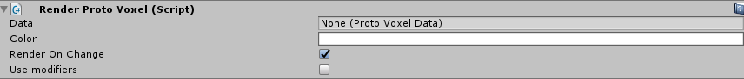
- Data: This will be information of a voxel to be rendered, we will see this in the next step.
- Color: A color to be multiplied to the voxel information, this way you can have multiple objects using the same Voxel Data with different colors.
- Render On Change: If you apply any change to the voxel data and this option is on, you will see the changes happening in real time.
- Use Modifiers: Modifity this voxel only for this GameObject, we will see this later on.

So, first we need to create a Voxel Data so our GameObject can render it.
Create a folder in the Assets, and with the right mouse button, create a ProtoVoxelData:
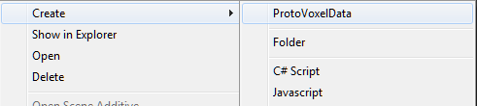

Once you create this object, you will see in the inspector this information:
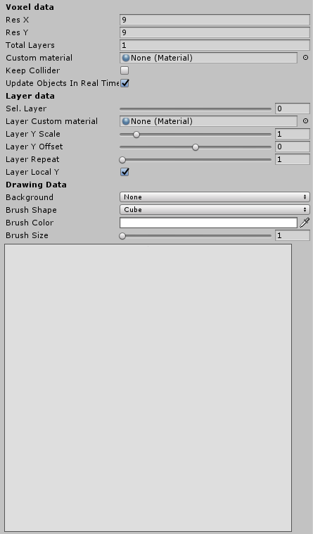

This is where the magic happens, you create a voxel by drawing a image in a 2D canvas. So lets go by all elements:
- Voxel Data:
  - Res X/Y: How much pixels you want your canvas in the X/Y axis, this create more detail for you to drawn.
  - Total Layers: A voxel is created from multiple 2D layers, each layer stack on top of the last one, you can set how much layers your final voxel will have with this.
  - Custom Material: The voxel will use the standard material, or you can set a new material here that will be used by this voxel.
  - Keep Colliders: Will add colliders to the voxel if on.
  - Update Objects In Real Time: If on, any object in the scene that have this Voxel will update in real time while you drawn in the canvas.
- Layer Data:
  - Sel Layer: The inspector will show the information and canvas of the selected layer.
  - Layer Custom Material: If you want a material only for this layer, it will override the default material.
  - Layer Y Scale: The Y scale can be changed to create a taller layer.
  - Layer Y Offset: Make this layer hover above or overlay with the last later.
  - Layer Repeat: Create multiple copies of this layer on top of each other, good for towers and alike.
  - Layer Local Y: Make the position of this layer relative to the last layer. If turned off the layer will appear on Y = 0 position of the voxel.
- Drawing Data:
  - Background: While drawing in the canvas, you can render the lower Layer or upper layer to get a reference, making it easier to draw.
  - Brush Shape: You can drawn squares, that are the most common in voxels, or you can select another prefabs, even a custom GameObject to use as a brush.
  - Brush Color: Set the color that will be used in the canvas:
  - Brush Size: Control the size of the brush

So, once you got everything set up, just start to draw, for me, I made little sun with two layers (Layer 1, Layer 2):
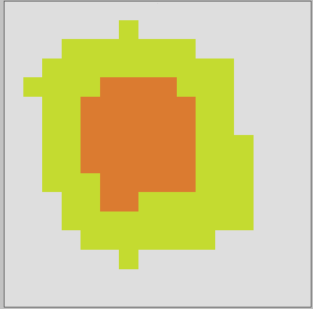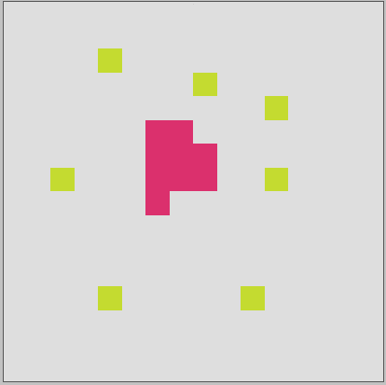

So, lets add this information to our RenderProtoVoxel:
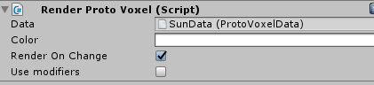
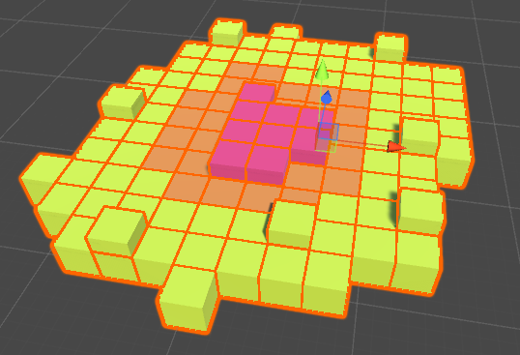
TADA! Instantly we have a sun in our scene (if render on change is turned on)
So, let’s see those modifiers parameters inside RenderProtoVoxel:
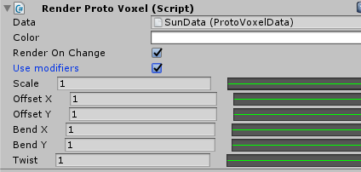
- Scale: Control the scale of the voxel, the animation curve control the scale from -Y to +Y using the float value.
- Offset X/Y: Offset each layer by a value, use the animation curve to control the offset in the X/Y axis.
- Bend X/Y: Bend each layer, creating a curve effect in the voxel.
- Twist: Rotate each layer.

So, using the sun example, let’s use the “Layer Repeat” to create a small tower with our sun:
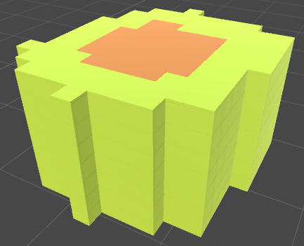

Set see each modifier:
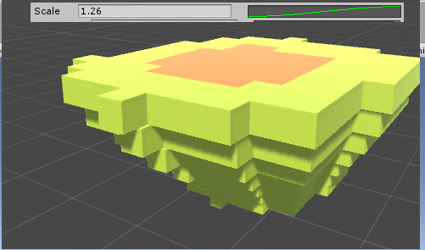
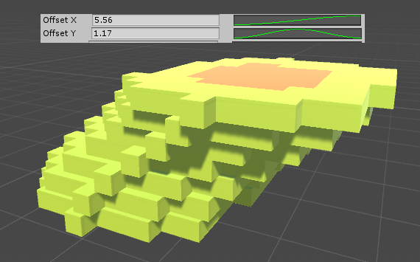
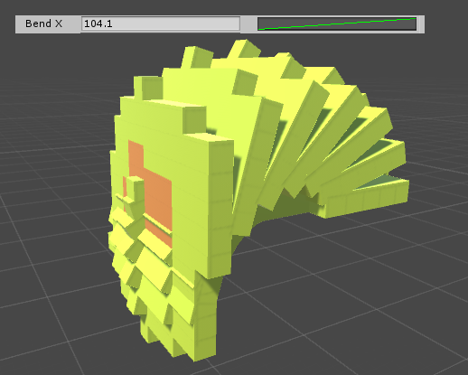
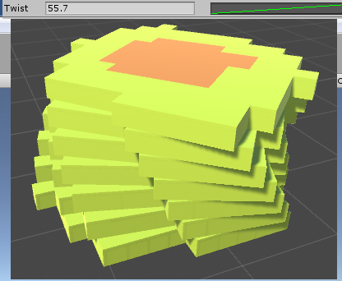

Now we can animate each of these modifiers if we want, just add the ProtoVoxelAnimate script:
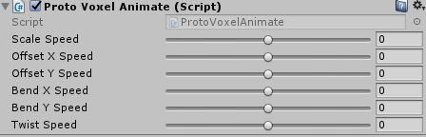
Just set the speed you want each value to be updated and hit play, and this is all!

